Moving Sale
Home Brew System and Brewing Accessories for Sale
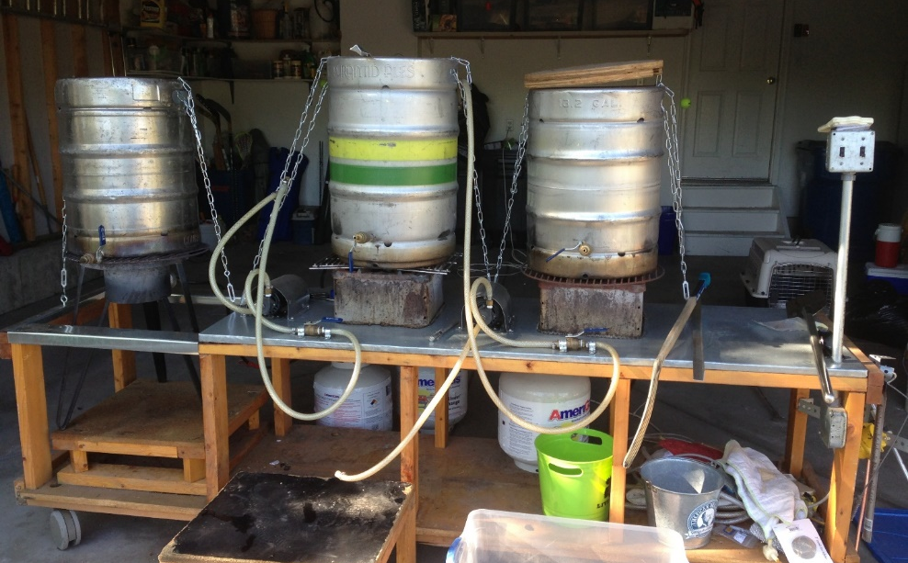
$550 or $700 with 3-Propane tanks
( >$1500 Value! )
Ready to step up your all-grain brewing system? This home-built brew system has everything you need for brewing award winning beers. This 3-keg, 3-burner, 2-transfer pump system allows you to easily brew up to 12+ gallon batches using up to 32 lbs of grain in the 16-gallon mash/lauter tun. With the transfer pump approach, you no longer need to lift boiling water over your head! The hop-back can be used to filter any grain or leaf hops before entering the food-grade centrifugal pumps.
Transferring the wort through the counterflow chiller can be done efficiently by cascading the transfer pumps for a higher flow rate. The auto-sparge rotates to evenly distribute sparging waters over the grain bed.
The galvanized steel topped cart rolls easily to wherever you want to brew and rolls away for storage.
Brew System |  |  | Additional Accessories Included
3 – Kegs with screens, covers, screens, safety chains, and fittings (1-16 gal, 2-13.2 gal) | Galvanized-top cart with high quality wheels |  | ~60 lbs of grain (Vienna, Munich, Pale, adjuncts) | Motorized Schmidling Adjustable 2-roller Malt Mill – mill, motor, flywheel, safety shroud, power cord w- on/off switch
2 – GRI 17650 Food-grade Magnetic Transfer pumps w-tubing | 3 - Keg thermal temperature wraps |  | Immersion chiller | Stirring paddles
2 - Box style burners | Auto-Sparging arm
1 - Cajun burner
1 - Hop-back | Counterflow chiller
Brew System
Chuck
720-320-1192
Brew System
Chuck
720-320-1192
Brew System
Chuck
720-320-1192
Brew System
Chuck
720-320-1192
Brew System
Chuck
720-320-1192
Brew System
Chuck
720-320-1192
Brew System
Chuck
720-320-1192
Brew System
Chuck
720-320-1192
Brew System
Chuck
720-320-1192

